VPC CHALLENGES
VPC-Endpoint_and_Transit-Gateway
CHALLENGE: Start working on the below challenge.
Use Case: Setting up Transit Gateway and VPC Endpoints for a Multi-VPC Architecture
Scenario:
A large organization is migrating its on-premises infrastructure to the AWS cloud.
The organization's architecture involves multiple VPCs for different departments and
applications, each requiring secure communication with centralized services and external
resources.
The IT team needs to design and implement a scalable and efficient network architecture to
accommodate the organization's growth and ensure robust connectivity between VPCs
and external services.
Objectives:
Design and deploy a scalable network architecture using AWS Transit Gateway to simplify
network connectivity between multiple VPCs.
• Configure VPC endpoints to securely access AWS services without internet gateways or
NAT gateways, ensuring data privacy and minimizing exposure to external threats.
Step 1: Create VPCs
Create three VPCs.
• APP VPC (10.0.0.0/16)
• DB VPC (10.20.0.0/16)
• SERVICES VPC (10.30.0.0/16)

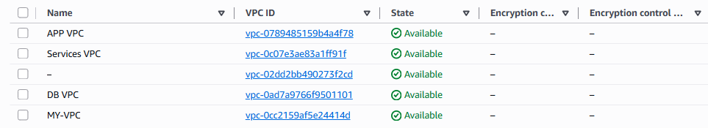
SUBNETS

ROUTE-TABLE
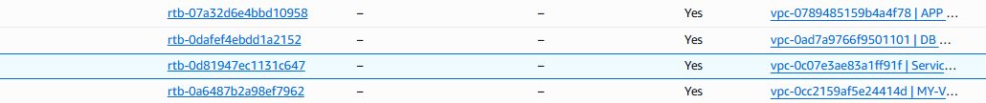

Go to
VPC → Transit Gateways → Create Transit Gateway
Provide
• Name
• Amazon ASN (Default)
• Enable DNS Support
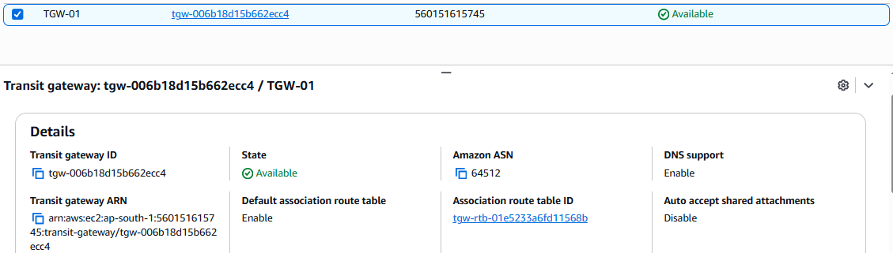

Attach VPCs to Transit Gateway
Select the subnet in each VPC.
Wait until the Attachment status becomes Available
Go to
Transit Gateway → Attachments → Create Attachment
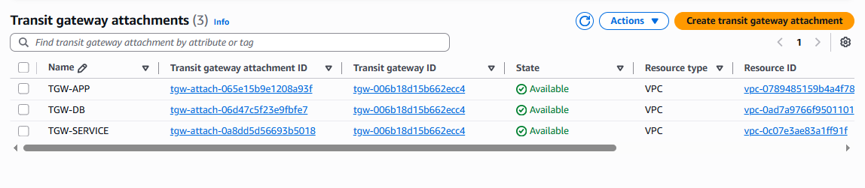

Update Route Tables
In every VPC Route Table, add routes:

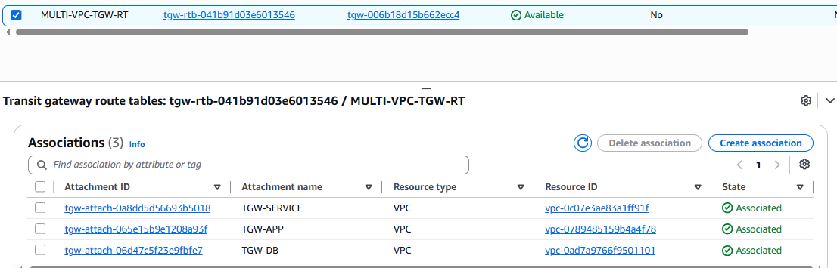

Configure Security Groups
Allow required ports like:
Allow ICMP (Ping)
or
• SSH (22)
• HTTP (80)
• HTTPS (443)

Test Connectivity
From EC2-A
ping <Private-IP-of-EC2-B>
ping <Private-IP-of-EC2-C>
Connectivity should succeed through the Transit Gateway.
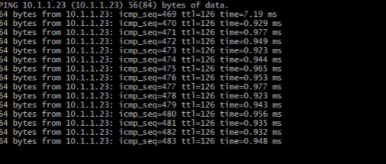
Create VPC Endpoint
VPC → Endpoints → Create Endpoint
Choose the AWS service.
Example:
> S3 (Gateway Endpoint)
> DynamoDB (Gateway Endpoint)
> SSM (Interface Endpoint)
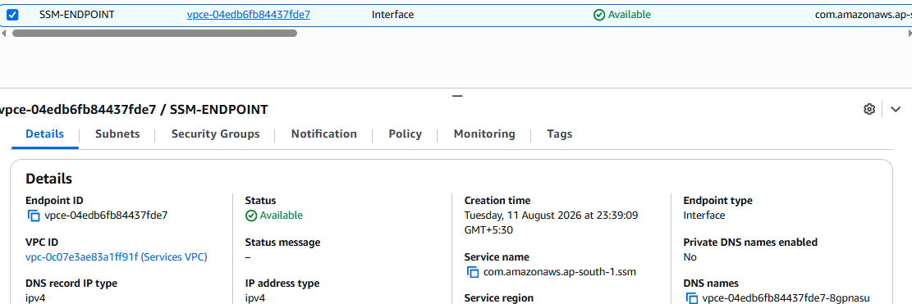
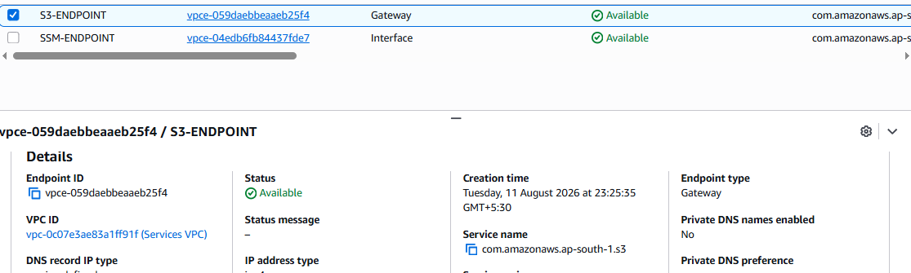
ssss
Configure VPC endpoints to securely access AWS services without internet gateways or
NAT gateways.
An S3 Gateway Endpoint is specifically designed so EC2 instances can access Amazon S3without using an Internet Gateway or NAT Gateway.
